EX NO: 6 | Configure firewall in Router Using Cisco Packet Tracer
DATE:

Objective :
- To configure a Cisco router as a firewall using Extended Access Control Lists (ACLs).
- To control communication between secured and untrusted networks by permitting and denying specific network traffic based on defined security policies.
Software/Apparatus required:
- Cisco Packet Tracer
- End Devices (PCs)
- Switches
- Copper Straight-through Cable / Automatic Cable Selector
- Routers
- Server

Networking diagram

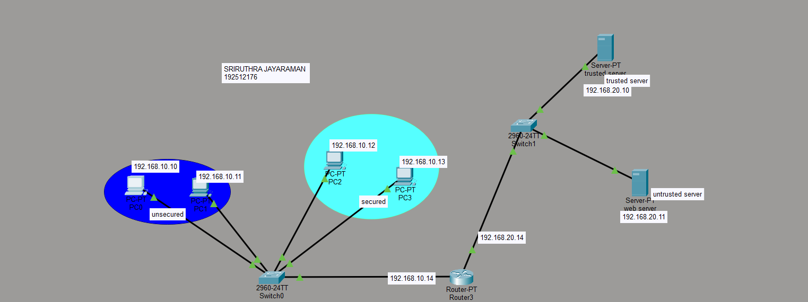

Output:

SI.  No | Source IP | Destination IP | Data sent (bytes) | Data received (bytes)
 | 192.168.10.10 | 192.168.20.10 | 4 | 4
 | 192.168.10.11 | 192.168.20.10 | 4 | 4
 | 192.168.10.12 | 192.168.20.11 | 4 | 0
 | 192.168.10.13 | 192.168.20.11 | 4 | 0
 | 192.168.10.12 | 192.168.20.10 | 4 | 4
 | 192.168.10.13 | 192.168.20.10 | 4 | 4
 | 192.168.10.10 | 192.168.20.11 | 4 | 4
 | 192.168.10.11 | 192.168.20.11 | 4 | 4
 | 192.168.20.10 | 192.168.10.10 | 4 | 4
 | 192.168.20.10 | 192.168.10.11 | 4 | 4
 | 192.168.20.11 | 192.168.10.12 | 4 | 4
 | 192.168.20.11 | 192.168.10.13 | 4 | 4
 | 192.168.20.10 | 192.168.10.12 | 4 | 4
 | 192.168.20.10 | 192.168.10.13 | 4 | 4
 | 192.168.20.11 | 192.168.10.10 | 4 | 4
 | 192.168.20.11 | 192.168.10.11 | 4 | 4

Procedure

- Design the network topology consisting of:
  - Unsecured Network o Secured Network o Trusted Web Server o Untrusted Web Server o Router acting as a firewall
- Assign IP addresses to all hosts and router interfaces.
- Verify basic connectivity using the ping command.
- Enter global configuration mode on the router: Router# configure terminal
- Create an Extended ACL to deny communication between secured hosts and the untrusted web server:
access-list 100 deny ip host 192.168.10.12 host 192.168.20.11 access-list 100 deny ip host 192.168.20.11 host 192.168.10.12 access-list 100 deny ip host 192.168.10.13 host 192.168.20.11 access-list 100 deny ip host 192.168.20.11 host 192.168.10.13 access-list 100 permit ip any any
- Apply the ACL to the router interface: interface fa0/0 ip access-group 100 in
- Exit configuration mode and save the configuration:
end write
- Test connectivity:
  - Ping the trusted server from all hosts. o Ping the untrusted server from unsecured hosts.
  - Verify that secured hosts cannot ping the untrusted server.

Result

Objective 1: The Cisco router was successfully configured as a firewall using Extended Access Control Lists (ACLs). The configured ACLs effectively enforced the defined security policies by filtering network traffic between the secured and untrusted networks.
Objective 2: Communication from the secured hosts (192.168.10.12 and 192.168.10.13) to the untrusted web server (192.168.20.11) was successfully blocked, while access to the trusted web server remained available. The unsecured network hosts were able to communicate with both the trusted and untrusted web servers according to the specified security policy.

Test Case Question 1
Implement the specified network topology using a Cisco router as a firewall and configure Extended ACLs to control communication between secured and unsecured networks.
Case 1
- Number of Routers: 1
- Number of Switches: 3
- Number of Unsecured Hosts: 2 (PC0, PC1)
- Number of Secured Hosts: 2 (PC2, PC3)
- Number of Servers: 2 (Trusted Web Server, Untrusted Web Server)
- Firewall Mechanism: Extended ACL
Security Policy
- Unsecured hosts can access both the Trusted and Untrusted Web Servers.
- Secured hosts can access only the Trusted Web Server.
- Secured hosts must be denied access to the Untrusted Web Server.
Tasks
- Construct the specified topology, configure IP addressing, and verify network connectivity.
- Configure the Cisco router as a firewall using Extended ACLs to implement the specified security policy.
- Test and validate the firewall configuration by verifying permitted and denied communication between hosts and servers.

Test Case Question 2
Implement the specified network topology using a Cisco router as a firewall and configure Extended ACLs to restrict communication between selected hosts and servers.
Case 2
- Number of Routers: 1
- Number of Switches: 3
- Number of Hosts: 4 (PC0, PC1, PC2, PC3)
- Number of Servers: 2 (Trusted Web Server, Untrusted Web Server)
- Firewall Mechanism: Extended ACL
Security Policy
- PC0 and PC1 can access both web servers.
- PC2 can access only the Trusted Web Server.
- PC3 must be denied access to both web servers.
- Communication between PC3 and all other hosts must be blocked.
Tasks
- Construct the specified topology, configure IP addressing, and verify network connectivity.
- Configure the Cisco router as a firewall using Extended ACLs to implement the specified security policy.
- Test and validate the firewall configuration by verifying permitted and denied communication between hosts and servers.

